### 

### Tourism Recommendation System

### Using

### Machine Learning

### Abstract

This study proposes an intelligent Tourism Recommendation System (TRS) that utilizes machine learning algorithms to provide personalized travel recommendations. By analyzing user preferences, historical data, and online reviews, the TRS generates accurate suggestions for destinations and activities. The system incorporates collaborative filtering and deep learning models to enhance recommendation accuracy. Additionally, sentiment analysis techniques are employed to consider the sentiments expressed by other travelers. The TRS benefits both individual travelers and tourism industry stakeholders by assisting in decision-making and optimizing business operations. Extensive evaluations demonstrate the effectiveness and accuracy of the proposed system.

## Acknowledgement

#### TABLE OF CONTENTS

**CHAPTER NO.**

**DESCRIPTION PAGE NO.**

Abstract i

Acknowledgement ii

Table of Contents iii

List of Figures iv

List of Tables v

1. INTRODUCTION
   1. Relevance of the Project 2
   2. Machine Learning Algorithms 3
2. LITERATURE SURVEY
   1. Machine Learning Based Short-Term Travel Time Prediction 4
   2. Tourist Prediction using Machine Learning Algorithms 6
   3. Machine Learning based Tourism Recommendation System 8
   4. Machine Learning Algorithms for building Recommender 9

Systems

* 1. Tourism Recommender System using Machine Learning 11

1. PROBLEM DEFINITION AND OBJECTIVES
   1. Problem Statement 13
   2. Objective 13
2. SYSTEM REQUIREMENTS AND SPECIFICATION
   1. Functional Requirements: 15
   2. Non-Functional Requirements: 15
   3. Hardware Requirements 16
   4. Software Requirements 16
3. SYSTEM ANALYSIS
   1. System Architecture Diagram 22
   2. Use Case Diagram 23
   3. Data Flow Diagram 24
   4. Sequence Diagram 26
4. **IMPLEMENTATION**
   1. Admin Module 30
   2. Tourism Data set Module 32
   3. User Authentication Module 33
5. **TEST CASES** 35
6. **RESULT ANALYSIS** 37

**CONCLUSION AND FUTURE SCOPE** 42

**APPENDIX A:** Abbreviations 44

**APPENDIX B:** Publication Details 45

**REFERENCES**

# LIST OF FIGURES

|  |  |  |
| --- | --- | --- |
| **FIGURENO.** | **DESCRIPTION** | **PAGENO.** |
| 2.1 | RF algorithm flow chart | 16 |
| 5.1 | System Architecture | 22 |
| 5.2 | Use Case Diagram | 23 |
| 5.3 | Data Flow Diagram | 24 |
| 5.4 | Sequence Diagram | 26 |
| 8.1 | Sign Up Page | 38 |
| 8.2 | Email Confirmation | 38 |
| 8.3 | Sign in Page | 39 |
| 8.4 | Home Page | 39 |
| 8.5 | User Input | 40 |
| 8.6 | Generated Plan | 40 |
| 8.7 | Route Generation on Map | 41 |
| 8.8 | Admin Page | 41 |

|  |  |  |
| --- | --- | --- |
|  | **LIST OF TABLES** |  |
| **TABLE NO.** | **DESCRIPTION** | **PAGE NO.** |
| 7.1 | User Authentication | 35 |
| 7.2 | Trip Plan mapping based on User Preferences | 35 |
| 7.3 | User Interface Testing | 36 |
| 7.4 | Handling Edge Cases | 36 |

iv

**CHAPTER 1**

# INTRODUCTION

The Tourism Industry is constantly evolving, and with the rise of digital technology and the vast amount of information available online, travelers are seeking personalized and tailored recommendations for their trips.

Tourism Recommendation System using machine learning has emerged as a powerful solution to meet these demands. By leveraging the capabilities of machine learning algorithms, such a system can analyze vast amounts of data, learn from user preferences and behavior, and provide personalized recommendations for destinations, accommodations, attractions, activities, and more.

Machine learning algorithms have the ability to identify patterns, trends, and correlations within large datasets, allowing the tourism recommendation system to understand user preferences, interests, and travel behavior. This information is crucial in generating accurate and relevant recommendations that align with each individual traveler's unique preferences.

Traveling and taking breaks from work help workers feel less stressed. Stress affects focus, thus stress-relieving holidays can aid in regaining focus by lowering stress levels. People have a variety of holiday location selections, but sometimes our vacation options aren't great all the time to visit every place because some destinations are only well-known and worthwhile visiting during a specific season. As a result, picking a destination based on data from the Internet and other sources is the most challenging duty to complete before or after travel preparation.

There are various systems that offer people recommendations for travel, however some technical, system, and usability accuracy have been overlooked. In-depth knowledge of decision-making is required for information seeking in order to solve this issue. As a result, we have suggested a decision tree-based system for recommending travel destinations.

This technique will assist in gathering more information based on the opinions of those who have visited the locations. It will provide recommendations for every targeted location. The Admin and User modules make up this recommender system. The administrator has the power to examine and add locations. Users can view the opinion analytics connected to their selected place based on reviews.

Great travels aren't prepared; they just happen. There are many activities that may be done on road journeys to help people connect with their loved ones and friends. Moving away from a consistent Internet connection allows for more in-depth conversations, nostalgic songs to be heard, the opportunity to relive embarrassing and humorous old stories (which, admit it, you kind of like), and, most importantly, the opportunity to make new memories. After all, the real destination of a road trip is always the journey itself. And what harm does a brief diversion do if it results in an unforgettable experience in a town you otherwise would not have known about? By taking your time, you can allow for spontaneity and the emergence of some amazing unanticipated events. One of the most exciting and amazing experiences in life is taking a road trip.

It conveys the thrill and adventure of both the destination being visited and the overall road trip. When preparing for a trip, one of the most common challenges people face is determining the optimal route to reach their destination. Additionally, individuals often wish to identify potential tourist attractions along the way and determine the best time to visit these sites. While existing research has primarily focused on finding routes that minimize specific trip costs, such as travel time or distance, little attention has been given to incorporating user preferences into recommendation systems. Some systems solely provide information about the ideal timing for traveling to destinations.

To address these limitations, we have developed an application that addresses the aforementioned issues and aims to enhance people's travel experiences. Our application efficiently plans routes that include the user's preferred sites by leveraging their geographic locations. We prioritize creating visually appealing travel routes that encompass remarkable tourist sites. Moreover, we place emphasis on suggesting the optimal time to visit these destinations, eliminating the need for users to browse multiple sources to gather the necessary travel information.

Our application serves as a comprehensive platform that offers information on both the recommended route and the ideal travel timing, conveniently consolidating these details in one place.

###### Relevance of the Project

The relevance of a tourism recommendation system project lies in its potential to enhance the overall tourism experience for travelers and provide valuable assistance in trip planning. The main

purpose of this project is to suggest the most optimal routes to the specified destination considering the user’s interests to visit multiple destinations on the way to their final destination.

This application also saves the user’s time by providing all the necessary information required to travel to the destination in one place instead of the user spending his time on acquiring all this information from different sources. Many tourists tend to visit popular tourist spots, missing out on lesser-known but equally captivating attractions. A tourism recommendation system can leverage user-generated content, expert reviews, and other data sources to uncover hidden gems and off-the- beaten-path locations that travelers may not have discovered otherwise. It has the potential to enhance the travel experience, save time, promote sustainable tourism, support local businesses, and contribute to data-driven decision making. These factors make it highly relevant in today's travel landscape, where personalized and convenient experiences are increasingly sought after by travelers.

###### Machine Learning Algorithms

Machine learning refers to the application of artificial intelligence (AI) techniques that enable systems to acquire knowledge and enhance their performance through experience, without the need for explicit programming. The field of machine learning centers around the creation of computer programs capable of accessing and utilizing data to autonomously acquire knowledge. The learning process commences with the collection of observations or data, such as examples, firsthand experience, or instructions, in order to identify patterns within the data and make informed decisions based on the provided examples. The primary objective is to enable computers to learn and adapt their actions automatically, without requiring human intervention. In our project, we employ machine learning to forecast the most optimal user pathway, taking the user's interests into account. We thoroughly examined various machine learning algorithms to determine the most suitable one for implementing our project.

**CHAPTER 2**

# LITERATURE SURVEY

The current project incorporates ideas and findings from various academic papers focused on travel-related topics and the prediction of current and future conditions in specific areas. The following sections provide an overview of the main concepts and findings extracted from these papers to address various relevant concerns.

###### Machine Learning Based Short-Term Travel Time Prediction

In the study conducted by researchers [1], machine learning techniques were employed to predict short-term travel times based on data collected from the RITIS (Regional Integrated Transportation Information System). RITIS is an advanced traffic analysis system that utilizes probe data analytics, segment analysis, and signal analytics. For the case study, raw travel data from selected road segments along the I-485 freeway in Charlotte, North Carolina, were utilized. I-485 is a heavily traveled interstate freeway that encircles the city, with its final segment completed in June 2015. Over the past 25 years, the population of the Charlotte area has significantly increased from 688,000 to 1.4 million, and it is expected to grow by an additional 500,000 residents over the next 20 years. Charlotte is the largest city in the state and one of the fastest-growing metropolitan areas in the United States. Consequently, this rapid population growth has led to traffic congestion on major roads.

Specifically, the southern segments of I-485 in Charlotte experience recurrent congestion during weekdays, primarily due to heavy commuter and interstate traffic. This congestion not only affects travel times but also hinders further economic development in the area. To address this issue, the I- 485 Express Lanes project commenced in the summer of 2019 and is expected to be completed in 2022, with an estimated cost of 346 million dollars. The project involves adding one express lane in each direction along I- 485 between exit 67 (I-77) and exit 51 (U.S. 74). As a result, travel time reliability and traffic flow in these freeway segments are anticipated to improve. The selected sections are depicted in the accompanying figure, which illustrates a satellite map of the area.

* **TTP Methods**
  + 1. **Ensemble Learning**

The proposed approach in this study focuses on ensemble based learning, a supervised learning algorithm that combines multiple models to enhance performance. Specifically, our focus is on tree-based ensemble learning, which involves utilizing several base models, such as decision tree models, to provide alternative solutions to the problem at hand. By incorporating diverse models, the ensemble approach aims to improve the accuracy of prediction results. This is because the diversity among the models helps mitigate the high variance typically associated with individual decision tree models, which can lead to unstable prediction outcomes.

To better understand the rationale behind ensemble learning, it is valuable to consider its psychological underpinnings. In our daily lives, we often employ a similar approach by seeking the opinions of multiple experts before making important decisions. For instance, before undergoing a major surgery, we may consult several doctors for their expert opinions. Similarly, when considering the purchase of a car, we may read multiple user reviews to gather a comprehensive understanding of its pros and cons. Furthermore, in the realm of academic publishing, research papers are typically reviewed by several experts in the field before being accepted for publication. These real-life scenarios exemplify the notion that aggregating diverse perspectives can lead to more informed and robust decision making processes.

By leveraging the ensemble-based learning technique, we aim to harness the collective knowledge and diverse perspectives of multiple base models to improve the accuracy and stability of predictions in our study.

* + 1. **Random Forest**

The RF (Random Forest) algorithm is rooted in the concept of ensemble learning, which involves combining a large collection of uncorrelated decision trees. Each decision tree can produce a result when provided with a set of predictor values. The RF algorithm introduces randomness through the generation of multiple datasets from the original sample set using a method called bootstrap aggregating, also known as bagging. Bagging is an ensemble algorithm specifically designed to enhance the accuracy of machine learning algorithms by increasing randomness. During the bagging process, the RF algorithm constructs multiple models using the same original sample

dataset, thereby reducing variance (as depicted in Figure 3). RF extends the concept of bagging by building decision trees based on different bagging samples derived from the original training data. To promote diversity among the decision trees, the RF algorithm imposes constraints on the

features that can be used to build each tree. This constraint compels the trees to differ from one another in terms of the selected features. Over time, RF models have gained widespread application across various research fields due to their effectiveness and versatility.

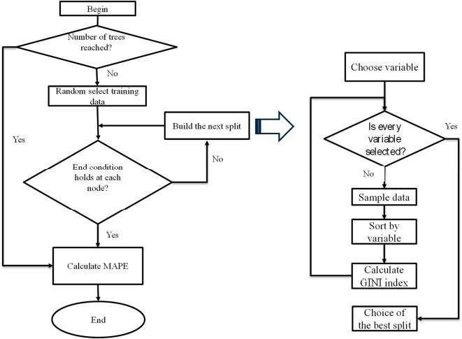

Fig 2.1: RF algorithm flow chart

###### Tourist Prediction using Machine Learning Algorithms

According to research [2], tourism plays a vital role in helping tourists familiarize themselves with the culture, customs, language, and way of life of the people at their destination. The benefits of tourism extend to job creation, foreign currency earnings, infrastructure development, poverty eradication, reduction of inequality, and balanced regional growth. Moreover, tourism is recognized for its contribution to global peace. Machine learning has emerged as a leading force driving technological innovation across various sectors, including tourism. It has brought about significant changes in the way the travel industry operates and commercializes its services.

Tourism forecasting has gained considerable attention from researchers, primarily due to the economic significance of tourism in national economies. Traditional techniques such as time-series analysis and regression models have been widely used for forecasting in tourism research.

Although these methods have shown some success, the introduction of machine learning approaches has the potential to greatly contribute to this field.

Machine learning algorithms, particularly those focused on prediction, have found applications in tourism analysis. This section delves into the various types of machine learning techniques and their utilization in analyzing tourism-related data. Association learning, a form of unsupervised learning, aims to uncover associations or relationships between different aspects of tourist behavior. On the other hand, classification learning, a supervised learning approach, involves training a model on a set of classified examples to classify unseen examples.

In the context of tourism, machine learning techniques are commonly used for three purposes: forecasting tourist expenses, analyzing tourist profiles, and predicting the number of tourist arrivals. This section provides a concise overview of ten machine learning techniques that support these activities. There are three uses of machine learning techniques in tourism are (1) forecast expenses of tourists, (2) analyzing profiles of ICSG 2020 K O C H I 2 0 2 0 tourists, and (3) forecast the number of tourist arrivals. In this section briefs for the ten machine learning techniques are used to support these activities.

* + 1. **Logistic Regression:** Logistic regression is a method that involves statistics of creating an equation to classify a large data set. It’s use is specific to predicting discrete values, such as binary outcomes (e.g., 0/1, yes/no, true/false), using independent variables. The output has probable logistic regression, and the predicted values fall within the range of 0 - 1, as expected. To achieve this, logistic regression calculates coefficients that enable the prediction of a logit transformation of the probability.
    2. **Linear Regression:** Linear regression involves creating a model or equation based on the available data. This model is later used to make predictions about a particular variable, also called the dependent variable or y, based on specific values of another variable called the independent variable or x, also called the predictor variable. By utilizing the linear regression model, estimation and forecast of the dependent variable based on the values of the independent variable can be possible.
    3. **Decision Tree:** It is a supervised learning algorithm commonly used for classification and regression tasks. It begins by selecting the best attribute from the dataset to serve as the root node. The training dataset is then divided into subsets based on the chosen attribute's features. This

splitting process continues recursively until all data is classified, resulting in the creation of leaf nodes at various branches. The decision on which feature to split on is determined by calculating the information gain, which helps identify the attribute that provides the highest amount of information. Decision trees are constructed to create a training model that can be utilized for predicting the class or value of the target variable.

* + 1. **Support vector machine:** The support vector machine (SVM) algorithm is a popularly used binary classifier. Introduced by Vapnik in 1995, SVM has gained popularity as a powerful machine learning technique and is a distinct group on its own. It makes use a separating hyperplane to establish decision boundaries among data points with different labels. SVM is a strictly supervised classification algorithm, meaning it optimizes an optimal hyperplane using input or training data to make decisions and classify new examples. Depending on the kernel employed, SVM can perform both linear and nonlinear classification tasks effectively.
    2. **Naive-Bayes:** This is a supervised classification method that builds classifiers based on Bayes' theorem. It is particularly useful for handling large datasets and is relatively easy to implement. The algorithm states that the occurrence of each feature is not dependent on the occurrence of other features, hence the "naive" assumption. This independence assumption simplifies the computation and makes classification efficient, especially when dealing with a vast amount of data. Naive Bayes requires a small number of training data for classification, and the computation of all terms can be pre-computed, leading to fast and effective classification. It leverages Bayes' theorem to calculate the posterior probability P(c|x) using prior probability P(c), evidence probability P(x), and conditional probability P(x|c). Overall, Naive Bayes is an advanced classification method that offers efficient and accurate classification based on probability calculations.

##### Machine Learning based Tourism Recommendation System

In this section, we will discuss previous publications that highlight the application of recommendation systems in the tourism industry. These studies employ various techniques, including machine learning and deep neural networks, to improve the recommendations provided to tourists. Lucas et al. developed a hybrid recommendation technique called the Personalized Sightseeing Planning System. Their system utilizes classification based on association in order to provide personalized recommendations for tourism activities. Another study by A. Umanets and colleagues introduced an application called Guide Me, which integrates with social networks. This

mobile app, available for both Android and iOS, suggests unexplored tourist destinations based on user ratings and preferences. Kulkarni focused on ranking tourist places based on positive and negative reviews using the Amazon Reviews datasets. They employed a deep learning algorithm to arrange the sequence of Points of Interest (POIs) in their recommendations. Jeong et al. proposed a recommendation system for the city of Seoul in South Korea using social network analysis. They argue that the personality type of the tourist plays a significant role in selecting a tourism destination. Wang developed a personalized travel product recommendation system that takes into account users' demographic variables such as age, gender, profession, and city, along with review data. The study utilized a large dataset of 1,283,715 reviews. G. H. Verma focused on rural tourism in India and used opinion mining with supervised machine learning to categorize sentiments from various travel-related companies, hotel reviews, and tourism agencies. They proposed a robust model based on the Term Frequency - Inverse Document Frequency (TF-IDF) metrics. Muthu Krishnan. adopted a lexicon-based and rule-based approach to sentiment analysis in order to extract tourist characteristics from mobile app reviews on Twitter. They categorized the reviews into different sentiments based on polarity. Zelenka. presented a conceptual framework for providing validated destination assessments and verified ratings of tourism services. They conducted case studies using Tripadvisor and Booking.com and developed a trust model by analyzing the review and verification processes of these websites. Paolanti et al. developed a deep learning geo data framework to define geographical, temporal, and demographic tourist flows within a tourist region. Their study evaluated the framework using a comprehensive dataset. Overall, these publications demonstrate the use of various techniques, including machine learning, deep learning, sentiment analysis, and social network analysis, to enhance recommendation systems in the tourism industry.

###### Machine Learning Algorithms for building Recommender Systems

* **Collaborative filtering (CF):** Collaborative filtering is a user-to-user association approach [8-9]. It is based on the concept that if multiple users have similar interests in one area, there is a higher likelihood that they will also be interested in similar products or items from other categories [3-4]. Similarity between users is computed using both implicit and explicit user ratings. Implicit ratings are derived from user browsing patterns and click-through rates, while explicit ratings are provided by users themselves. Platforms like Facebook utilize collaborative filtering to recommend friends, posts, pages, and other content based on factors such as mutual friends, similar interests, and shared locations.
* **Content-based filtering (CBF):** Content-based filtering focuses on the idea of "Show me more

of what I have liked." These systems recommend items to users that are similar to the ones they have enjoyed in the past [3-4]. The similarity between items is determined based on common features or attributes. For example, on YouTube, the browsing pattern of a user is observed to understand their preferences, and they are recommended similar content in the suggested videos section. Content-based filtering assumes that if a user likes an item from a specific category, they are likely to be interested in other items from the same category as well

* **Knowledge based systems (KBS):** Knowledge-based systems generate recommendations based on specific domain knowledge or expertise [3-4]. Users provide their needs or requirements to the system, which then compares those needs with its knowledge base to provide relevant suggestions. For instance, in an e-commerce site, users specify their desired features for a product, such as price range, color, and size. The system then recommends the most suitable products based on the match between the user's specifications and the product properties.
* **Hybrid recommender systems:** Hybrid recommender systems combine characteristics from multiple recommendation techniques to overcome the limitations of a single approach [3-4]. Netflix is an example of a popular hybrid recommender system that combines collaborative and content-based approaches. It suggests movies or series to users based on their interests, viewing history, and similarity to other users. For instance, if a user has shown a preference for romantic movies like "PS I Love You," "The Notebook," and "The Fault in Our Stars," Netflix will recommend other movies belonging to the romantic genre. Additionally, if two users have similar viewing patterns, they will be suggested content based on each other's preferences.

##### Tourism Recommender System using Machine Learning

* + 1. **Recommender System**

Recommender systems serve two primary objectives. Firstly, they aim to predict and understand a user's preferences and interests by analyzing their behavior or the behavior of similar users. This analysis enables the generation of personalized recommendations tailored to the user's individual preferences.

Secondly, recommender systems address the ranking aspect of the problem, known as the top-k recommendation problem. Instead of providing a specific answer, this approach recommends the top-k items to the user based on their preferences. Aggarwal has identified five fundamental models of recommender systems, as depicted in Figure 1.

The collaborative filtering model generates recommendations by considering user-item ratings from multiple users. In contrast, the content-based recommender system analyzes the attributes of users and items, focusing on individual users rather than considering the entire user population. Knowledge-based recommender systems generate recommendations based on explicitly stated user requirements, without relying on external knowledge bases or historical data.

Demographic recommender systems utilize demographic information about users to develop classifiers that map specific demographics to ratings or buying propensities. Lastly, hybrid recommender systems combine different approaches to create more robust techniques, leveraging the strengths of various recommender system types in different contexts.

* + 1. **Machine Learning Framework**

Machine learning (ML) is a computational approach that utilizes historical data to enhance performance and make accurate predictions. In this context, "experience" refers to the collection of past information stored in electronic format, and the quality and quantity of this data play a vital role in the learner's ability to make reliable predictions. ML can be categorized into three types of data:

* + - * Training data: This data set is employed by ML algorithms to acquire the necessary knowledge and skills to perform specific tasks.
* Validation data: This data is used to fine-tune the hyper parameters of a learning algorithm, optimizing its performance.
* Test data: This data is utilized to assess and evaluate the outcomes of the trained ML model.

Currently, numerous companies offer pre-trained ML frameworks that facilitate the prediction of specific tasks. These frameworks encompass libraries, platforms, models, and other essential components required for running ML. Developers can access these ML frameworks through APIs (Application Programming Interfaces) or micro-services.

**CHAPTER 3**

# PROBLEM DEFINITION AND OBJECTIVES

###### Problem Statement

Previous efforts have primarily focused on finding routes that minimize a single type of trip cost, such as travel time or distance. Some systems only provide information about the best time to travel to specific destinations. As a result, users often need to visit multiple websites to gather all the necessary information for their travel planning. For example, ‘TripAdvisor’ is a widely used travel recommendation platform that utilizes machine learning algorithms to deliver personalized suggestions to travelers.

By analyzing users' past behavior, preferences, and reviews, ‘TripAdvisor’ offers recommendations for hotels, restaurants, and attractions. Similarly, Booking.com employs machine learning algorithms to provide personalized recommendations based on users' previous bookings, searches, and reviews. The system also incorporates user feedback to enhance the accuracy of its recommendations.

###### Objectives

To address these limitations and enhance the travel experience for users, we are developing an application that offers comprehensive solutions. Our goal is to efficiently plan travel routes that encompass the user's preferred destinations, taking into account their geographical locations. We specifically aim to generate aesthetically pleasing travel routes that cover captivating tourist sites.

Moreover, our system will provide recommendations on the optimal travel times for various destinations, eliminating the need for users to navigate multiple platforms to gather such information.

Through our application, users will be able to input multiple preferences, ensuring a personalized travel experience. To achieve high accuracy in the suggested travel paths, we are implementing advanced algorithms. Additionally, our system incorporates a weather predicting classifier that accurately forecasts the best months to travel from the source to the destination. Overall, our application aims to simplify the travel planning process, offering users a convenient and

memorable travel experience.

The application takes the source and destination as input from the user. It also asks the user to select his/her interest. An optimal path from the source to the destination is created which covers all the site-seeing places according to the user’s interest. It displays this optimal path that is generated based on the user’s interest on a map for better user readability.

It also displays a directions panel where the distance from every source to every other destination is mentioned so that the user can have a clear idea of the distance he/she will have to travel between source and destination by covering the intermediate places. It also recommends the best time to travel by analyzing the weather data.

**CHAPTER 4**

# SYSTEM REQUIREMENTS SPECIFICATION

A Software Requirement Specification (SRS) is a detailed description of a software system to be developed with its functional and non-functional requirements. It may include the use cases of how the user is going to interact with the software system. The software requirements specification document is consistent with all necessary requirements required for project development. To develop software systems, we should have a clear understanding of software systems. To achieve this, we have to gather information accurately and meticulously.

##### Functional Requirements:

Functional requirements may involve calculations, technicalities, processing and data manipulation, and other specific functionality that define the accomplishment to be made by the system. The following are the functional requirements for our project: The user can enter the source and the destination:

* + - The application should generate common places of interest based on the region.
    - The user can select his/her places of interest from the generated places of interest.
    - The application should generate the most optimal path which includes almost all site-seeing spots of the user’s interest.
    - The application should suggest the best time to visit that region.
    - A map should display the optimal path.

##### Non-Functional Requirements:

Non-functional requirement specifies the criteria which can judge the operation of a system, instead just specific behaviors. The following are the non-functional requirements of our project:

* The optimal path must be generated without much delay.
* An accurate suggestion of the best time to visit the region must be made.
* The optimal path must be displayed on a map accurately.

###### Hardware Requirements:

Hardware requirement specifies the minimum hardware that is required for the application to run smoothly. The following are the hardware requirement for our project:

* Processor –Core i3
* Hard Disk – 160 GB
* Memory – 1GB RAM
* Monitor

###### Software Requirements:

Software requirement specifies the minimum software that is required for the application to run smoothly. The following are the software requirement for our project:

* Windows 7 or higher
* Python
* Django framework
* MySQL database
* CSS
  + 1. **Django**



Django, an open-source web framework built on Python, simplifies the development of complex, database-driven websites by adhering to the model-template-view (MTV) architectural pattern. It

promotes reusability, pluggability of components, minimal code repetition, low coupling, and speedy development.

Python serves as the primary programming language within Django, including for settings files and data models. Notably, Django offers an optional administrative interface that dynamically generates and configures through introspection and admin models. This interface enables CRUD operations (create, read, update, delete) for data.

While Django has its own terminology, such as labeling the objects generating HTTP responses as "views," the core framework aligns with the Model-View-Controller (MVC) architecture. It encompasses an object-relational mapper (ORM) that mediates between Python class data models (the "Model" component) and a relational database. Additionally, it features a web templating system (the "View" component) for processing HTTP requests and a URL dispatcher (the "Controller" component) based on regular expressions.

Alongside these foundational components, Django provides several other features within its core framework, such as:

* + - * A lightweight and standalone web server for development and testing purposes.
      * A form serialization and validation system that converts HTML forms to database-compatible values.
      * A template system that incorporates inheritance concepts from object-oriented programming.
      * A caching framework with support for various cache methods and middleware classes that allow custom functions to execute at different request processing stages.
      * An internal dispatcher system for inter-component communication through predefined signals.
      * An internationalization system with support for translations in multiple languages.
      * A serialization system for XML and JSON representations of Django model instances.
      * An extensible template engine and integration with Python's built-in unit testing framework. Furthermore, Django offers the Django REST framework, a flexible and powerful toolkit designed specifically for building web APIs. It simplifies API development, providing comprehensive tools and features to create robust and scalable web services.

In summary, Django empowers developers with a feature-rich and efficient framework for building web applications. It prioritizes code simplicity, reusability, and rapid development, making it an excellent choice for web development projects.

* + 1. **HTML**



Hypertext Markup Language (HTML) serves as the widely adopted standard markup language for creating web pages that are intended for display in web browsers. To enhance its presentation, HTML can be complemented with technologies like Cascading Style Sheets (CSS) and scripting languages such as JavaScript.

When a web browser retrieves an HTML document, either from a web server or local storage, it processes the document and transforms it into interactive multimedia web pages. HTML is responsible for defining the structural layout of a web page in a semantic manner, and it also originally included instructions for the visual appearance of the document.

HTML elements act as the fundamental building blocks of HTML pages. By utilizing HTML constructs, various elements like images and interactive forms can be embedded within the rendered page. HTML facilitates the creation of structured documents by assigning structural semantics to different types of text, such as headings, paragraphs, lists, links, quotes, and more. HTML elements are identified and enclosed within tags, which are written using angle brackets.

* + 1. **CSS**



Cascading Style Sheets (CSS) is a language specifically designed to describe how a document, typically written in a markup language like HTML, should be presented visually. CSS holds a crucial position as one of the core technologies of the World Wide Web, alongside HTML

and JavaScript.

The primary objective of CSS is to facilitate the separation between the presentation aspects and the content of a document. It achieves this by allowing the specification of layout, colors, fonts, and other presentational attributes. This separation brings numerous benefits, including improved accessibility of content, increased flexibility and control over presentation characteristics, the ability to share formatting across multiple web pages by employing a separate .css file, and a reduction in complexity and repetition within the structural content.

Moreover, the division between formatting and content empowers the rendering of the same markup page with different styles suitable for various output methods. For instance, CSS enables customization for on-screen display, printing, auditory rendering (through speech-based browsers or screen readers), as well as Braille-based tactile devices. CSS also incorporates rules for alternative formatting when the content is accessed through a mobile device.

* + 1. **Python**



Python is a versatile, interpreted programming language known for its high-level nature. It supports various programming paradigms, including structured (such as procedural), object- oriented, and functional programming. Python is dynamically typed and incorporates a garbage collection feature. It is often hailed as a language that comes with an extensive collection of libraries, hence referred to as "batteries included."

Python can be described as an interpreted, object-oriented, and high-level programming language that exhibits dynamic semantics. It offers built-in data structures at a high level and employs dynamic typing and dynamic binding, which makes it highly attractive for rapid application development. Python is also frequently utilized as a scripting or glue language to connect existing components together. Its simplicity and easily understandable syntax prioritize readability, resulting in reduced costs associated with program maintenance. Python promotes modularity and code reuse through its support for modules and packages.

The Python interpreter, along with its vast standard library, is freely available in both source and binary formats for major platforms, allowing for unrestricted distribution. Due to the absence

of a compilation step, the edit-test-debug cycle in Python is notably swift. Debugging Python programs is a straightforward process, as errors or faulty input do not lead to segmentation faults. Instead, when the interpreter encounters an error, it raises an exception. If the program fails to handle the exception, the interpreter prints a stack trace, providing valuable insights into the issue. Python's introspective power is evident in its source-level debugger, which permits variable inspection, evaluation of expressions, setting breakpoints, step-by-step code execution, and more. Notably, the debugger itself is implemented in Python, showcasing the language's introspective capabilities. However, it is worth mentioning that adding print statements to the source code is often an effective and efficient way to debug programs, thanks to Python's rapid edit-test-debug cycle.

* + 1. **MySQL**



MySQL is a popular open-source relational database management system (RDBMS) widely used in the software industry. It offers a comprehensive range of features and functionalities for storing, managing, and retrieving structured data. MySQL adheres to the relational model, where data is organized into tables with rows and columns, enabling efficient data organization and retrieval.

One of the notable strengths of MySQL lies in its robust and scalable architecture. It is specifically designed to handle large data volumes and efficiently manage multiple concurrent connections. MySQL incorporates various optimization techniques, including indexing and caching, to enhance query performance and ensure smooth operation even under heavy workloads.

MySQL fully supports the widely adopted SQL language, enabling users to interact with the database through intuitive and standardized commands. SQL provides a rich set of operations for creating, modifying, and querying databases, making it straightforward to work with MySQL.

Another essential feature of MySQL is its support for transactions, which ensures data consistency and integrity. By adhering to the ACID (Atomicity, Consistency, Isolation, Durability)

properties, MySQL guarantees that a group of database operations either completes successfully or rolls back to their initial state in case of any failure. This capability is particularly vital when dealing with critical and sensitive data.

As an open-source database system, MySQL benefits from a large and active community of developers and users. This vibrant community contributes to the continuous development and improvement of MySQL and provides valuable resources such as comprehensive documentation, forums for discussion, and libraries for extending its functionality.

In summary, MySQL is a robust and scalable RDBMS with a wide range of features. Its adherence to the relational model, support for SQL language, transaction capabilities, and active community contribute to its popularity and usefulness in managing structured data in various software applications.

**CHAPTER 5**

# SYSTEM ANALYSIS

###### System Architecture Diagram

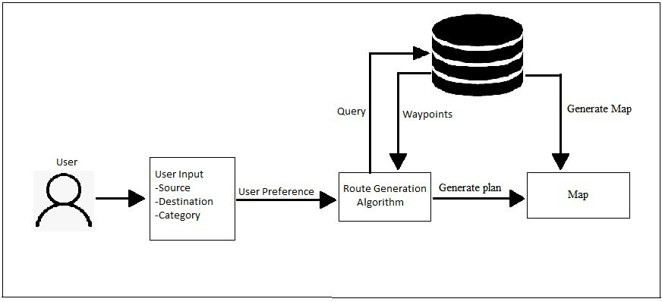

Fig 5.1 System Architecture

Fig 5.1 depicts the architecture of our trip recommendation system. The main components of system architecture diagram include:

* + - User Input: The user selects the source and the destination from the drop-down consisting of 30 districts and selects the category of places they want to visit as well.
    - Database: The database contains way-points along with the district they belong to and the category they fall under.
    - Route Generation Algorithm: The user input is given to the route generation algorithm. The algorithm queries the database to get the way-points which fall under the selected categories, generates the plan from source to the destination considering the way-points which fall under the user's selected category along the way.
    - Map: The output from the Route Generation Algorithm is given as input to the optimal route page. With the help of Google map API the path is plotted in the map and the other information along with the best months to travel from source to destination is also given in the side pane.

###### Use Case Diagram

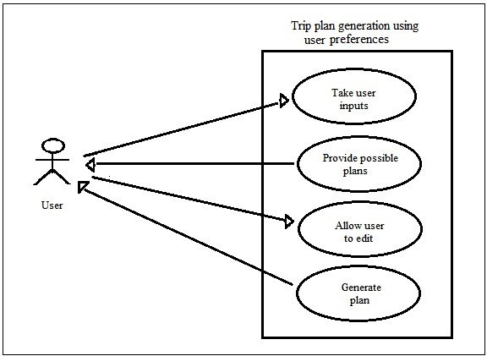

Fig 5.2 Use Case Diagram

Fig 5.2 depicts the architecture of our trip recommendation system. The main components of the use case diagram include:

* + - User Profile Creation: the user profile is created by the by providing some basic information like her preferred travel destinations, interests (e.g., adventure, culture, food), budget, and trip duration. Additionally, she may connect her social media accounts or provide previous travel history to enhance the system's understanding of her preferences.
    - Personalized Recommendations: Once the user's profile is created, the recommendation system utilizes machine learning algorithms to analyze her profile data, historical travel patterns, and similar user behavior. Based on this analysis, the system generates personalized recommendations for the user. These recommendations may include popular tourist destinations, must-visit attractions, highly-rated hotels, and recommended restaurants known for local cuisine.
    - Real-time Updates: As the user interacts with the system and provides feedback on recommended places or updates her travel plans, the recommendation engine dynamically adjusts the suggestions. For example, if the user rates a recommended attraction highly, the system will take that into account and provide similar attractions in the future. If she modifies

her travel dates or budget, the system will adapt the recommendations accordingly.

* + - Exploration and Booking: The user can explore the recommended destinations, attractions, hotels, and restaurants in detail. The system provides comprehensive information such as descriptions, photos, user reviews, ratings, and pricing. The user can filter and sort the recommendations based on her preferences, location, budget, or other criteria. Once the user finds a suitable option, the system can facilitate direct booking or provide links to external booking platforms.
    - Trip Planner: The recommendation system can also offer trip planning functionalities. the user can create itineraries, add recommended places to her trip plan, and optimize the schedule based on travel distances, opening hours, and estimated visit durations. The system can even suggest nearby attractions or events that align with her interests.
    - User Feedback and Reviews: After the user completes the trip, the system encourages her to provide feedback and reviews for the recommended places she visited. This feedback helps improve the system's recommendations for future users and also allows other travelers to make informed decisions based on her experiences.

###### Data Flow Diagram

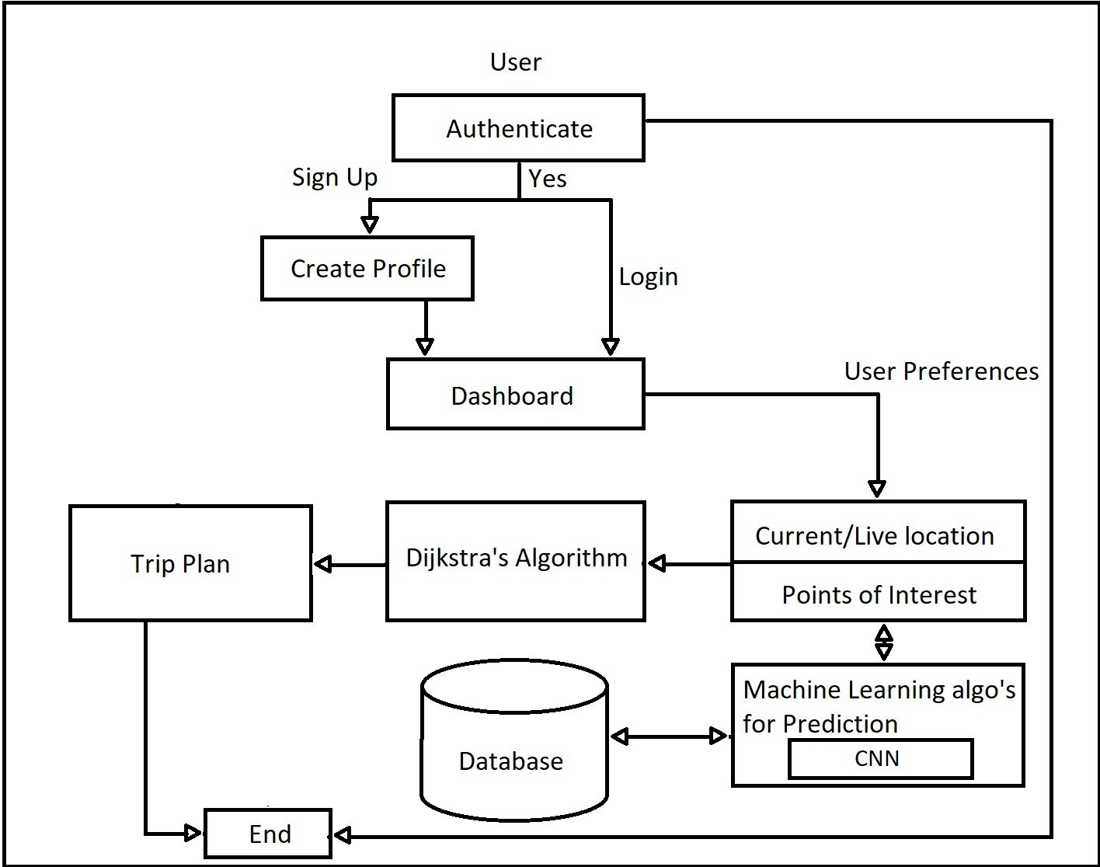

Fig 5.3 Data Flow Diagram

Fig 5.3 depicts the data flow of our trip recommendation system. A data flow diagram (DFD) is a graphical representation that illustrates the flow of data within a system. In a tourism recommendation system project, the DFD shows the data movement between different components and processes. The key elements of the DFD are:

* + - User Input: At the start of the data flow diagram, users interact with the system by providing input through a user interface. This can include creating a user profile, specifying preferences, entering trip details, and providing feedback on recommendations.
    - User Profile Management: The user input data is captured by the system and processed by the user profile management component. This component handles the creation, updating, and retrieval of user profiles. It stores and manages user preferences, travel history, and other relevant information that helps personalize recommendations.
    - Data Analysis and Recommendation Engine: The user profile data is fed into the data analysis and recommendation engine component. This component utilizes machine learning algorithms to analyze user preferences, historical data, and other relevant factors. It generates personalized recommendations for tourist destinations, attractions, hotels, restaurants, and other points of interest based on the user's profile.
    - Data Integration: The recommendation engine component retrieves and integrates data from various sources, including tourism databases, online travel platforms, review websites, and social media platforms. This data integration process ensures that the recommendations are based on up-to-date and comprehensive information about tourist destinations, attractions, and other relevant entities.
    - Recommendation Generation: The recommendation engine generates the personalized recommendations based on the integrated data and user profile analysis. These recommendations are passed on to the user interface component for display to the user.
    - User Interface: The user interface component presents the recommendations to the user through a user-friendly interface, such as a web application or a mobile app. The recommendations are displayed in a visually appealing and informative manner, providing details about the suggested destinations, attractions, hotels, restaurants, and associated information like reviews, ratings, and pricing.
    - User Feedback Management: The user interface component also captures user feedback and interactions. Users can provide feedback on the recommended places, rate their experiences, and share reviews. This feedback is passed on to the user profile management component for further analysis and improvement of the recommendation engine.
    - External Systems and APIs: The DFD may also include interactions with external systems and APIs. For instance, the system may integrate with external booking platforms to facilitate direct bookings for recommended accommodations or restaurants. It may also integrate with social media APIs to provide social sharing options or retrieve additional user data.

The data flow diagram provides a clear visual representation of how data flows through the various components and processes of the tourism recommendation system. It showcases the interaction between the user, user profile management, data analysis and recommendation engine, user interface, and external systems. This diagram helps in understanding the system's data flow, highlighting the key processes and components involved in generating personalized recommendations for users.

###### Sequence Diagram

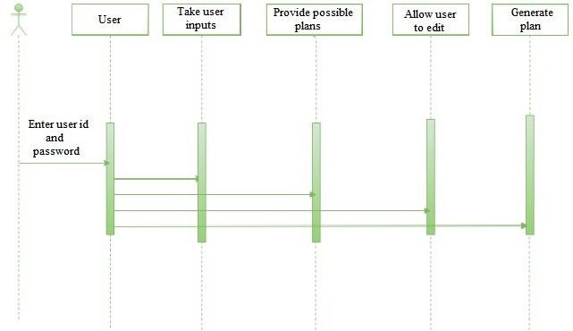

Fig 5.4 Sequence Diagram

Fig 5.3 depicts the sequence diagram of our trip recommendation system. A sequence diagram is a type of interaction diagram that illustrates the flow of messages and interactions between different components or actors in a system. In a tourism recommendation system project, a sequence diagram showcases the sequence of actions and messages exchanged between the user, system components, and external entities. Let's explore the key elements of the sequence diagram:

* + - User Interaction: The sequence diagram begins with the user initiating an interaction with the system. This can include actions like logging into the system, creating a user profile, or requesting personalized recommendations.
    - User Profile Component: Upon receiving the user's request, the system's user profile component processes the user's data and preferences. It verifies the user's credentials during login or creates a new user profile if the user is new to the system. The user profile component retrieves and stores user-specific information such as preferences, travel history, and feedback.
    - Recommendation Engine: Once the user profile is established or updated, the system's recommendation engine component comes into play. It receives the user's preferences and utilizes machine learning algorithms to analyze the data. The recommendation engine generates personalized recommendations for tourist destinations, attractions, hotels, and restaurants based on the user's profile and historical data.
    - External Data Integration: The recommendation engine component may interact with external systems or APIs to gather additional data for generating recommendations. It retrieves information from tourism databases, online travel platforms, review websites, or social media platforms to ensure comprehensive and up-to-date recommendations.
    - Recommendation Display: The generated recommendations are then passed back to the user interface component. The component of user interface presents the recommendations along with a user-friendly interface to the user, such as web app or a mobile application. The recommendations are displayed with relevant details, such as descriptions, photos, ratings, and reviews, to help the user make informed decisions.
    - User Interaction and Feedback: The user interacts with the user interface component, exploring the recommended options and providing feedback on their preferences. The user may rate attractions, leave reviews, modify preferences, or request additional recommendations based on specific criteria like budget or travel dates.
    - External System Integration: In some cases, the user interface component may interact with external systems or APIs. For example, when a user decides to book a recommended hotel or restaurant, the UI component may communicate with external booking platforms to facilitate the booking process.
    - Continuous Learning and Improvement: As the user provides feedback and interacts with the system, the user profile and recommendation engine components continuously learn and improve the recommendations for future interactions. The feedback is captured and analyzed to enhance the recommendation algorithms and personalize the recommendations further.
    - The sequence diagram provides a visual representation of the interactions and flow of messages between the user, system components, and external entities in the tourism recommendation system. It showcases the sequential order of actions and the exchange of information during the login process, recommendation generation, feedback collection, and integration with external systems. This diagram helps in understanding the system's behavior and the sequence of events that occur when a user interacts with the system to receive personalized recommendations.

#### CHAPTER 6

# IMPLEMENTATION

* **Data collection:** In this step, you need to gather relevant data related to tourism. This can include information about tourist destinations, attractions, hotels, restaurants, user reviews, ratings, and other pertinent details. You can acquire this data from various sources such as online travel platforms (e.g., Expedia, TripAdvisor), tourism websites, social media platforms (e.g., Instagram, Facebook), and review websites (e.g., Yelp, Google Reviews). APIs provided by these platforms can be utilized to fetch data programmatically.
* **Data preprocessing:** Once you have collected the data, it is crucial to preprocess it to ensure it is in a suitable format for machine learning algorithms. This step involves cleaning the data by removing duplicates, handling missing values (e.g., by imputing or deleting them), and addressing inconsistencies. Additionally, you may need to normalize numerical data to bring it within a specific range and perform text preprocessing techniques like tokenization (breaking text into individual words or phrases), stemming (reducing words to their base form), and removing stop words (commonly used words that do not carry much meaning).
* **Feature engineering:** Feature engineering involves selecting and creating meaningful features from the data that will serve as inputs to the machine learning model. For tourism recommendations, features can include the location of tourist destinations, ratings and reviews of attractions, amenities available at hotels, historical significance of a place, popularity of destinations, and any other relevant characteristics that can help in making recommendations.
* **Define the recommendation problem:** Determine the specific type of recommendation problem you want to solve. It could be personalized recommendations for individual users based on their preferences and behavior or general recommendations that are not personalized. Understanding the problems, you aim to solve will guide your subsequent steps.
* **Choose a recommendation algorithm:** There are various recommendation algorithms you can choose from, depending on the nature of the problem and the available data. Some common approaches include collaborative filtering, content-based filtering, matrix factorization, and hybrid models. Collaborative filtering relies on user-item interactions to find patterns and make recommendations, while content-based filtering uses the characteristics of items to make suggestions. Matrix factorization techniques like Singular Value Decomposition (SVD) or Alternating Least Squares (ALS) can also be employed. Hybrid models combine multiple

approaches to inculcate the strengths of different algorithms.

* Training the model: Split the pre processed data into training and testing sets. The training set trains the machine learning model, and the testing set is used to evaluate its performance. The model learns from the training data by identifying patterns and relationships between user preferences and item characteristics. The chosen recommendation algorithm is applied to train the model and generate recommendations based on the provided features.
* Evaluation: Evaluate the performance of the trained model using appropriate evaluation metrics. Common evaluation metrics for recommendation systems include precision, recall, mean average precision, and accuracy. These metrics assess the effectiveness of the recommendation system in providing relevant and useful recommendations to users. Evaluation helps identify any shortcomings and provides insights for model refinement.
* Deployment: Once the model is trained and evaluated, it can be deployed in a production environment. This involves integrating the recommendation system into a web or mobile application, allowing users to interact with the system and receive personalized or general recommendations based on their preferences. The deployed system should handle real-time user requests efficiently and deliver recommendations effectively.
* Continuous improvement: To enhance the recommendation system over time, it is essential to monitor its performance and collect feedback from users. User feedback can be obtained through explicit feedback such as ratings and reviews or implicit feedback such as user behavior and interactions with the recommended items. This feedback can be used to retrain the model periodically, incorporating.

###### Admin Module

The admin module of a tourism recommendation system using machine learning plays a crucial role in system management and maintenance. It encompasses various functionalities for data management, system configuration, monitoring, and administrative tasks. Here are key components and features that can be included in the admin module:

* + - User management: The admin module allows managing user accounts, including creating new accounts, updating user information, and handling authentication and authorization. This functionality grants the admin control over user access and privileges within the system.
    - Data management: Data management features enable the admin to handle the system's data. This includes data ingestion, cleaning, and preprocessing. The admin can upload new data, update existing data, and perform tasks such as removing duplicates, handling missing values, and

normalizing data.

* + - **Model management:** In a machine learning-based recommendation system, the admin module facilitates the management of recommendation models. It includes training and retraining models, updating model parameters, and monitoring performance. The admin can upload new models, initiate training, schedule periodic updates, and monitor key metrics like accuracy and relevance.
    - **Content management:** Content management features allow the admin to handle tourist destination-related content, such as attractions, hotels, and restaurants. This includes adding new content, updating existing content, and removing outdated or irrelevant information. The admin can also categorize and tag content to improve recommendation accuracy.
    - **Configuration management:** Configuration management functionalities enable the admin to customize system parameters and settings. This includes selecting recommendation algorithms, defining feature weights, adjusting thresholds, and tailoring system behavior. The admin can fine-tune these configurations based on user feedback and system performance.
    - **Monitoring and analytics:** The admin module provides monitoring and analytics capabilities to track system performance and user behavior. It includes monitoring uptime, tracking user activity, analyzing interactions with recommendations, and collecting feedback and reviews. These insights help the admin identify issues, improve recommendation accuracy, and make data-driven decisions.
    - **Reporting and insights:** Reporting functionalities generate insights and reports based on system data and user feedback. This includes reports on popular destinations, trending attractions, user preferences, and satisfaction metrics. The admin can utilize these reports to gain a deeper understanding of user behavior and make informed decisions to enhance the recommendation system.
    - **System maintenance and updates:** The admin module facilitates system maintenance tasks, such as backups, upgrades, and bug fixes. It supports version control and rollback mechanisms to handle updates and changes effectively.
    - **Security and privacy:** The admin module addresses security and privacy concerns by implementing access controls, encryption, and data protection measures. It ensures secure handling of user data and compliance with relevant privacy regulations.

These functionalities can be implemented through a web-based admin interface or a dedicated admin API that interacts with the underlying recommendation system. The admin module empowers system administrators to manage and optimize the tourism recommendation system,

ensuring its smooth operation and continuous improvement.

###### Tourism Dataset Module

The tourism dataset module in a machine learning-based tourism recommendation system is responsible for managing and handling the dataset used for training and evaluating the recommendation models. It encompasses several key components and functionalities:

* + - **Data collection:** The dataset module collects tourism-related data from diverse sources such as online travel platforms, tourism websites, social media platforms, and review websites. This may involve web scraping techniques or utilizing APIs provided by these platforms to fetch the data. The collected data includes information about tourist destinations, attractions, hotels, restaurants, user reviews, ratings, and other pertinent details.
    - **Data preprocessing:** Preprocessing the collected data is an important step performed by the dataset module. This includes cleaning the data by eliminating duplicates, addressing missing values, and handling any inconsistencies. Textual data, such as user reviews, may undergo preprocessing techniques like tokenization, stemming, and stop word removal.
    - **Data integration and fusion:** The dataset module integrates and fuses data from multiple sources to create a comprehensive dataset. It ensures that relevant information is properly merged while handling any discrepancies or conflicts. For instance, integrating data about tourist destinations, attractions, and user reviews into a unified dataset.
    - **Feature extraction:** The dataset module extracts meaningful features from the dataset to represent tourist destinations, attractions, or user preferences. These features can include location, ratings, reviews, amenities, historical significance, popularity, or other attributes relevant to making recommendations.
    - **Dataset splitting:** The dataset module splits the preprocessed dataset into training and testing subsets. The training set is utilized to train the recommendation models, while the testing set is used to evaluate their performance. The dataset splitting ensures that the models are trained on representative data and can generalize well to unseen data.
    - **Data augmentation:** In some cases, the dataset module employs data augmentation techniques to enhance the dataset's diversity and size. This involves generating additional samples by applying transformations or introducing variations to the existing data. Data augmentation helps improve the robustness and generalization capabilities of the recommendation models.
    - **Dataset management:** The dataset module handles the storage and organization of the dataset. It ensures that the dataset is appropriately stored and accessible for training and evaluation

purposes. The module may offer functionalities for dataset versioning, backup, and retrieval to facilitate efficient dataset management.

* + - **Dataset updating**: The dataset module enables periodic updates to the dataset to incorporate new data or reflect changes in the tourism domain. This involves adding newly collected data, updating existing data, or removing outdated or irrelevant data. Regular dataset updates ensure that the recommendation models remain up-to-date and provide relevant recommendations.
    - **Data privacy and security:** The dataset module addresses data privacy and security concerns. It implements measures to protect sensitive user data and comply with relevant data privacy regulations. This may include encryption of sensitive data, access controls to limit data exposure, and anonymization techniques to ensure user privacy.

The tourism dataset module plays a vital role in providing high-quality data for training and evaluating recommendation models. It ensures the proper processing, integration, and management of data, enabling accurate and effective tourism recommendations.

###### User Authentication Module

The user authentication module is an essential component of a tourism recommendation system that utilizes machine learning. It provides the functionality to authenticate and authorize users accessing the system. Here are the key aspects and functionalities of the user authentication module:

* **User registration:** The authentication module allows users to create an account by providing necessary details such as username, password, and possibly additional information like email address or contact number. It securely stores the user credentials to facilitate future authentication.
* **User login:** The module enables registered users to log into the system using their credentials. It verifies the provided username and password against the stored information to authenticate the user's identity.
* **Authentication mechanisms:** The authentication module may support various authentication mechanisms to enhance security. These mechanisms can include password-based authentication, multi-factor authentication (MFA) using methods like SMS verification codes or email confirmation.
* **Password management:** The module incorporates password management features to ensure secure storage and handling of user passwords. This may involve techniques like password hashing and salting to protect against unauthorized access in case of a data breach.
* **Authorization:** Along with authentication, the module manages user authorization within the

system. It assigns specific access rights and privileges to users based on their roles or permissions. For example, an admin user may have access to system configuration and user management, while regular users may have access to personalized recommendations and profile settings.

* **Session management:** The module tracks and manages user sessions to maintain user authentication throughout their interaction with the system. It assigns a session ID or token upon successful authentication and validates it for subsequent requests to ensure authorized access.
* **Account recovery:** In the event of a forgotten password or account recovery requests, the authentication module provides a mechanism for users to reset their passwords or regain access to their accounts. This may involve sending password reset links via email or SMS verification codes.
  + - **Security measures:** The module implements security measures to fight common attacks, for example, brute-force attacks, session hijacking, or account enumeration. It may include mechanisms like rate limiting, CAPTCHA verification, or IP blocking to mitigate these risks.
    - **Logging and auditing:** The authentication module maintains logs and audit trails of user authentication activities for security and compliance purposes. This includes recording successful logins, failed login attempts, and other relevant authentication-related events.
    - **Integration with other system components:** The authentication module integrates with other components of the tourism recommendation system, such as the recommendation engine or user profile module, to provide personalized and secure recommendations based on the authenticated user's preferences.

The user authentication module ensures that only authorized users can access the tourism recommendation system, safeguarding user accounts and providing a secure user experience.

**CHAPTER 7**

# TEST CASES

* 1. **User Authentication**

|  |  |
| --- | --- |
| Input | The user enters username and password. |
| Expected Output | The user gets logged in to the account and is guided to our user interface. |
| Actual Output | Login successful |
| Pass/Fail | Pass |

* 1. **Trip Plan mapping based on User Preferences**

|  |  |
| --- | --- |
| Input | A set of user inputs are taken to know their trip preferences |
| Expected Output | The tourism recommendation model correctly maps a plan based on each attribute selected by the user. |
| Actual Output | Trip plan for the specified number of days is generated. |
| Pass/Fail | Pass |

* 1. **User Interface Testing**

|  |  |
| --- | --- |
| Input | Interacting with the user interface of the Tourism Recommendation using Machine Learning. |
| Expected Output | The user interface is intuitive and responsive, allowing users to input their preferences and receive relevant trip plan suggestions effectively. |
| Actual Output | Users receive trip plan recommendations based on the preferences entered. |
| Pass/Fail | Pass |

* 1. **Handling Edge Cases**

|  |  |
| --- | --- |
| Input | Unusual or extreme, ambiguous, or unexpected inputs like request plans for more than a month or entering invalid/past dates. |
| Expected Output | The system handles edge cases gracefully, providing appropriate recommendations or indicating when accurate recommendations cannot be made due to uncertain inputs. |
| Actual Output | Results of extreme inputs are not generated accurately. |
| Pass/Fail | Fail |

**CHAPTER 8**

# RESULTS AND ANALYSIS

* **Personalized recommendations:** The tourism recommendation system leverages individual preferences, travel history, and user behavior to provide personalized recommendations to travelers. These tailored suggestions enhance the discovery of unique destinations, activities, and accommodations, enabling users to explore new and exciting options they may have overlooked.
* **Enhanced engagement and satisfaction:** By catering to specific interests and preferences, the system creates a more engaging and satisfying travel experience for users. By receiving recommendations aligned with their preferences, users are more likely to feel a sense of connection and enjoyment throughout their journey.
* **Improved efficiency:** The system benefits travel service providers, such as airlines, hotels, and tour operators, by matching their offerings with the needs and preferences of travelers. This improves operational efficiency by ensuring that travelers are presented with options that precisely align with their requirements, reducing time wasted on irrelevant choices.
* **Increased revenue:** Personalized recommendations present opportunities for travel service providers to increase revenue. By suggesting additional offerings, upselling relevant products and services, and cross-selling complementary experiences, providers can maximize the value they deliver to travelers and generate additional income.
* **Advanced data analysis:** The system collects and analyzes extensive data on traveler behavior and preferences. This data analysis yields valuable insights for travel service providers, empowering them to make data-driven decisions that enhance their services and offerings, ultimately optimizing their business operations.
* **Trust and loyalty:** By consistently delivering accurate and relevant recommendations, the system builds trust with travelers. When users receive recommendations that align with their preferences and result in enjoyable experiences, they develop loyalty towards the system and the associated travel service providers. This trust and loyalty contribute to a positive and fulfilling travel experience, fostering long-term relationships and increasing customer retention.

In summary, the tourism recommendation system's focus on personalized recommendations enhances engagement, satisfaction, and efficiency while driving revenue growth for travel service providers. The system harnesses advanced data analysis to provide valuable insights, fostering trust and loyalty among travelers. Overall, it strives to ensure a positive and fulfilling travel experience

for users and providers alike.

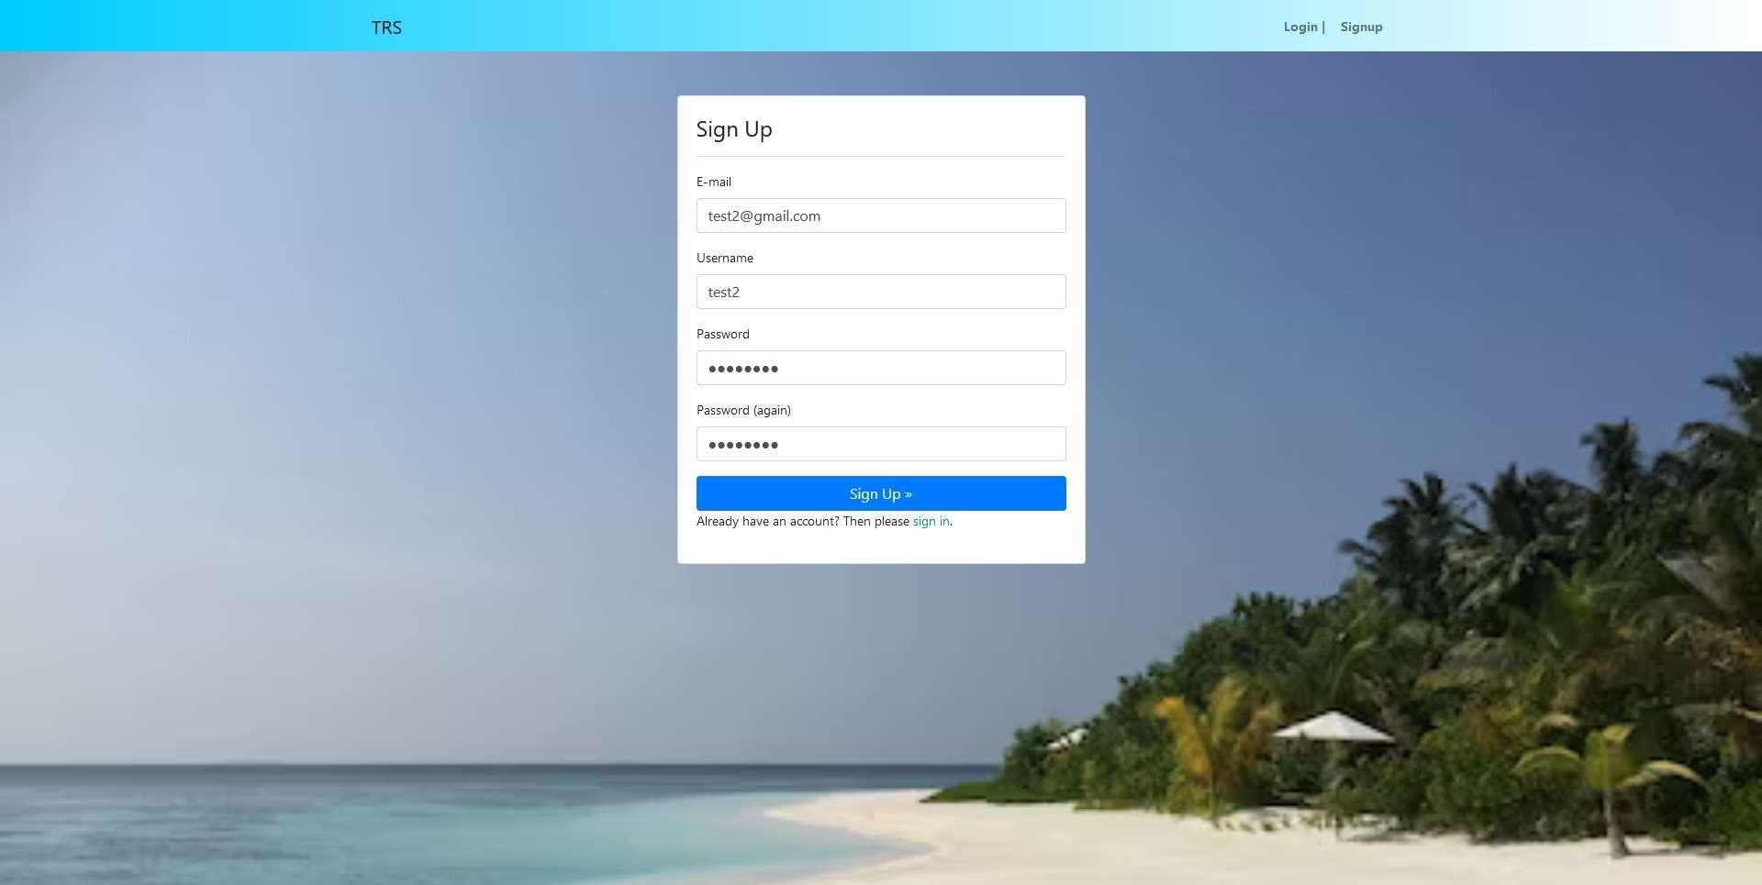

Fig 8.1 Sign Up Page

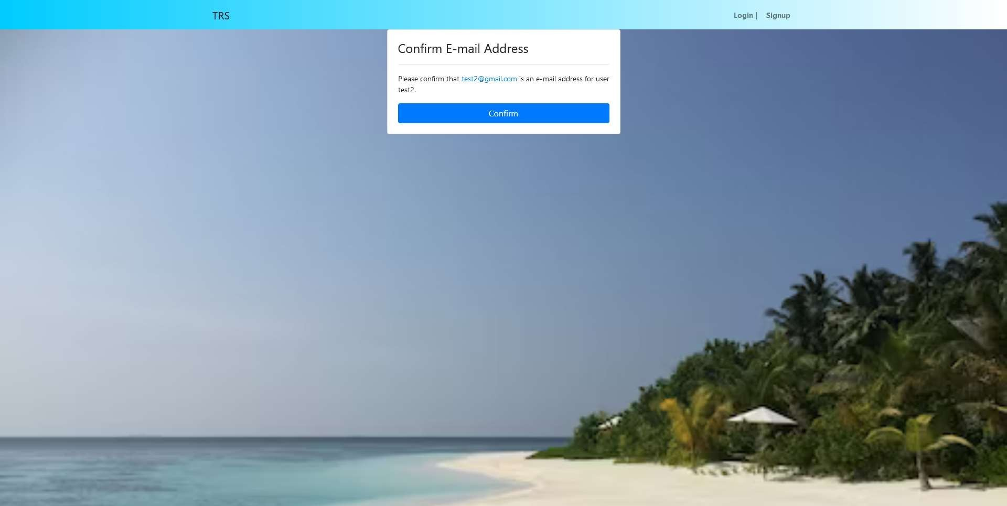

Fig 8.2 Email Confirmation

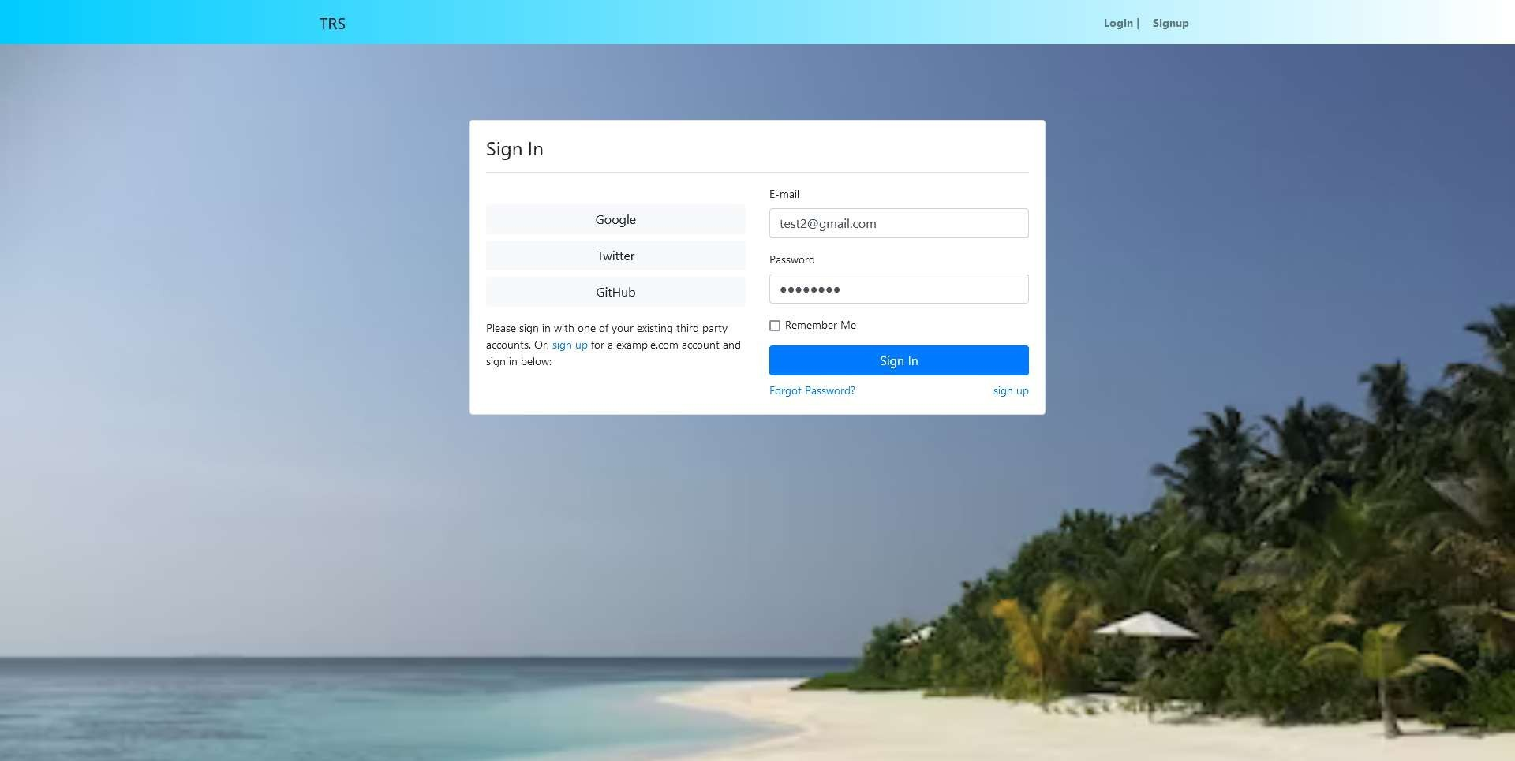

Fig 8.3 Sign in Page

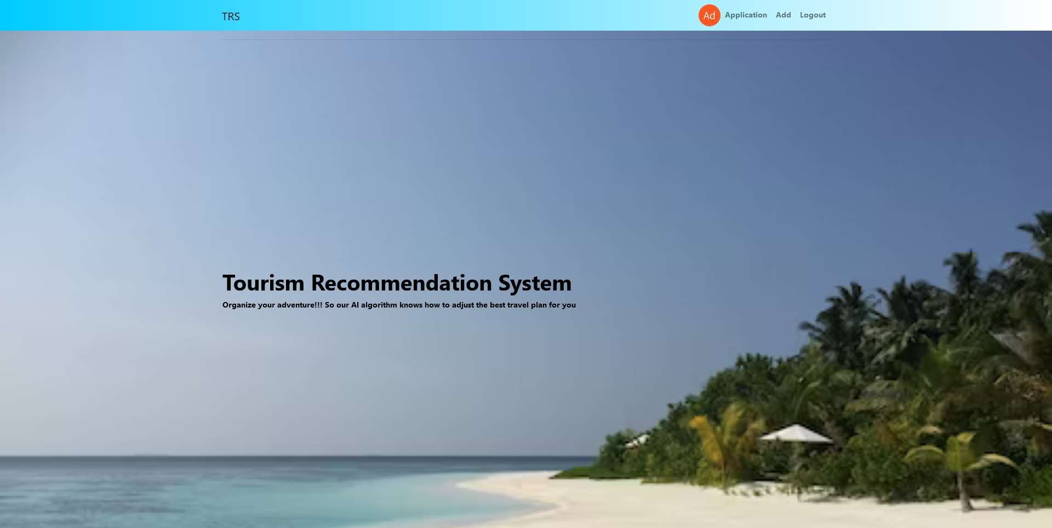

Fig 8.4 Home Page

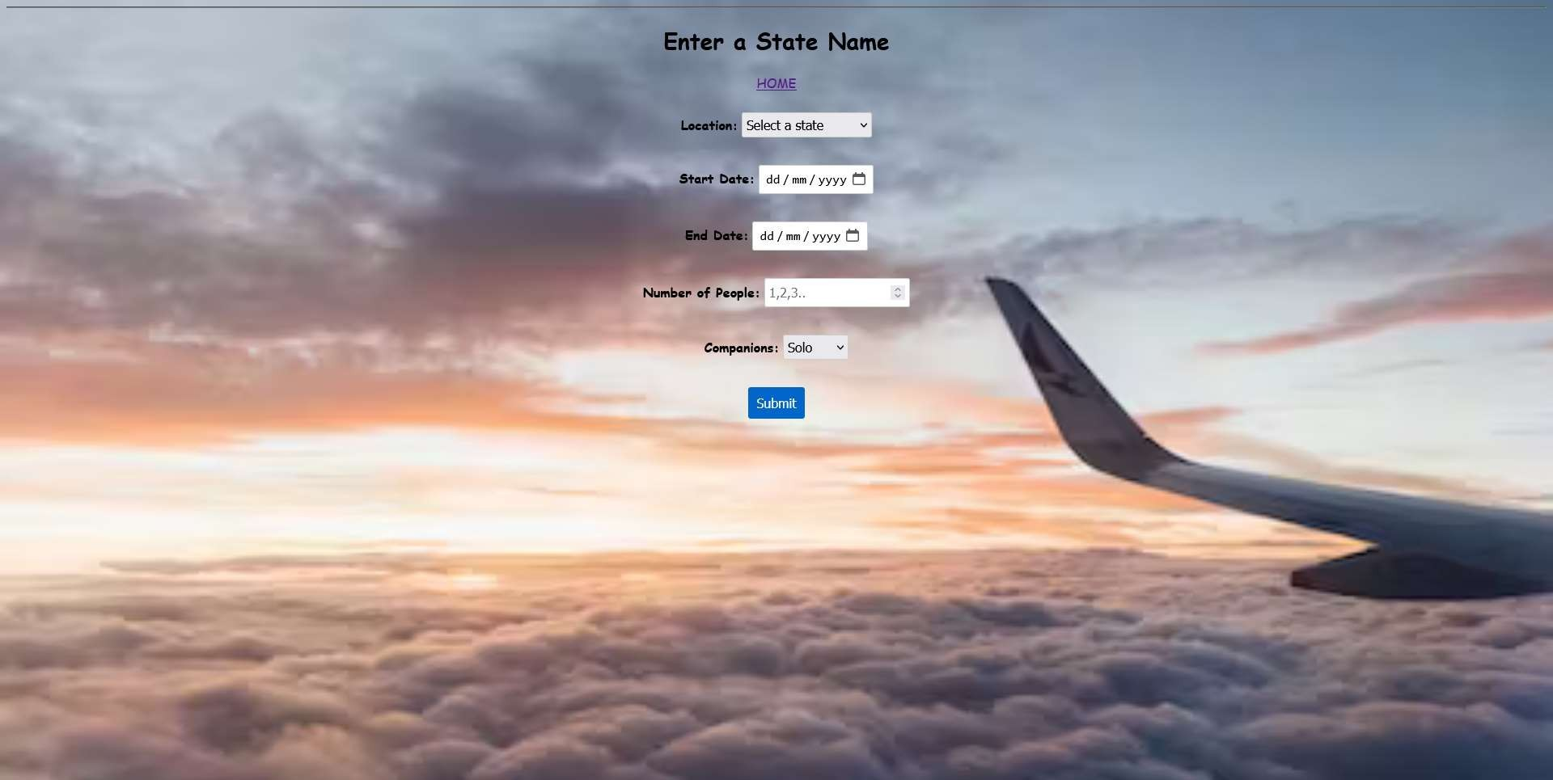

Fig 8.5 User Input



Fig 8.6 Generated Plan

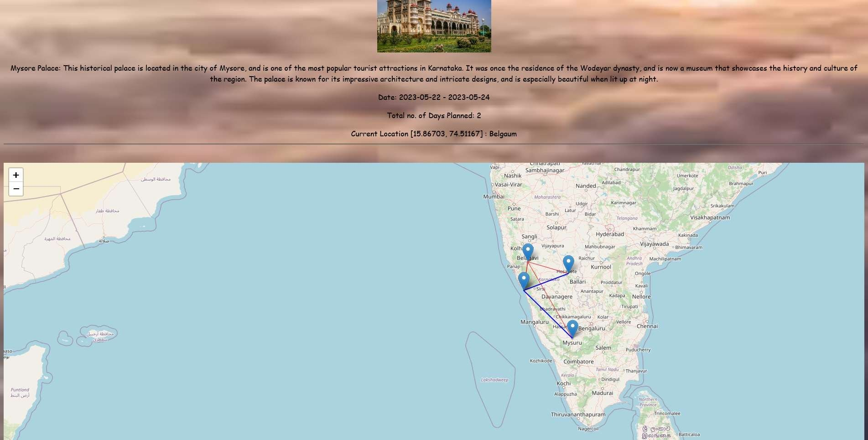

Fig 8.7 Route Generation on Map



Fig 8.8 Admin Page

**CHAPTER 9**

# CONCLUSION & FUTURE SCOPE

In conclusion, the Tourism Recommendation System using Machine Learning has emerged as a valuable tool in the travel industry, addressing the challenges faced by travelers in finding personalized and relevant recommendations. By leveraging machine learning algorithms, the system has the ability to analyze vast amounts of data, learn from user preferences, and generate tailored recommendations, thereby enhancing the overall travel experience.

Looking into the future, the scope of the Tourism Recommendation System using Machine Learning is promising. With advancements in technology and the availability of more diverse and real-time data sources, the system can further improve its accuracy and relevance in recommendations. It can incorporate advanced machine learning techniques, such as deep learning and natural language processing, to better understand user preferences and provide more personalized suggestions.

Additionally, the integration of other emerging technologies like ‘Augmented Reality’ (AR) and ‘Virtual Reality’ (VR) can enhance the user experience by offering immersive previews and virtual tours of destinations, accommodations, and attractions.

The future of Tourism Recommendation System also lies in its potential for collaboration and integration with other travel-related platforms and services. By partnering with travel agencies, airlines, hotels, local restaurants and other stakeholders, the system can provide a seamless and comprehensive travel planning experience for users, integrating recommendations with booking services, transportation options, recommendation of best hotel deals and itinerary planning.

Furthermore, as sustainability and responsible travel gain importance, the system can incorporate eco-friendly recommendations, promote sustainable tourism practices, and provide information on conservation efforts and local community involvement.

In conclusion, the future of the Tourism Recommendation System using machine learning holds opportunities for improved personalization, integration with emerging technologies, collaboration with travel industry stakeholders, and a focus on sustainability. By leveraging these advancements, the system has the potential to shape the future of travel by providing highly tailored and

immersive experiences, facilitating responsible tourism, and revolutionizing the way travelers explore and discover the world. This system has the potential to change the entire tourism industry effectively

#### APPENDIX-A

## Abbreviation

1. **TRS:** Tourism Recommendation System
2. **AI:** Artificial Intelligence
3. **ML:** Machine Learning
4. **CNN:** Convolution Neural Network
5. **KNN:** k-nearest neighbors
6. **CF:** Collaborative Filtering
7. **CB:** Content-Based Filtering
8. **DL:** Deep Learning
9. **NN:** Neural Networks
10. **AR:** Augmented Reality
11. **VR:** Virtual Reality
12. **SQL:** Structured Query Language
13. **API:** Application Programming Interfaces
14. **CSV:** Comma Separated Values
15. **DNN:** Deep Neural Network
16. **NLP**: Natural Language Processing
17. **RS:** Recommendation System
18. **UI:** User Interface
19. **UX:** User Experience
20. **Numpy:** Numerical Python
21. **Pandas:** Python and Data Analysis

# REFERENCES

1. Year: 2021, Authors: Bo Qiu and Wei (David)
2. Year : 2020, Authors: Bilal Adualgalil, Sajimon Abraham
3. https://shsu-ir.tdl.org/shsu-ir/bitstream/handle/20.500.11875/1164/0781.pdf?sequence=1
4. https://ieeexplore.ieee.org/document/6208293/
5. https://ieeexplore.ieee.org/document/4679917/
6. https://ieeexplore.ieee.org/document/9310777
7. https://dl.acm.org/doi/10.1145/3383972.3384074
8. https://[www.researchgate.net/publication/333857452_A_Machine_Learning_Approach_to_](http://www.researchgate.net/publication/333857452_A_Machine_Learning_Approach_to_) Building_a_Tourism_Recommendation_System_using_Sentiment_Analysis
9. https://[www.sciencedirect.com/science/article/pii/S2212017314004848](http://www.sciencedirect.com/science/article/pii/S2212017314004848)
10. https://[www.ijraset.com/research-paper/machine-learning-in-tourism](http://www.ijraset.com/research-paper/machine-learning-in-tourism)
11. Machine Learning Algorithms for building Recommender Systems
12. Staab, S., Werthner, H., Ricci, F., Zipf, A., Gretzel, U., Fesenmaier, D. R., ... & Knoblock,

C.(2002). Intelligent systems for tourism. IEEE Intelligent Systems, (6), 53-64

1. Berka, T., & Plößnig, M. (2011). Designing recommender systems for tourism. Proceedings ofENTER 2011, 26-28.
2. Alrasheed, H. et al, 2020, A multilevel tourism destination
3. Recommender system, Elsevier, p. 333-340
4. Bin et al, 2019, A travel Route recommendation System based on Smartphones and IoT Environments, Hindawi, vol. 2019
5. Jia, Z.Y., Gao, W., Shi, Y.J., 2016, An Agent Framework of Tourism Recommender System
6. Author : Richa Sharma Chitkara University Institute of Engineering and Technology,

ChitkaraUniversity, Punjab, India [richa.sharma@chitkara.edu.in](mailto:richa.sharma@chitkara.edu.in)

1. S. Loh, F. Lorenzi, R. Saldana, and D. Lichtnow, A tourism recommender system based on collaboration and text analysis, Information Technology & Tourism, vol. 6, no. 3, pp. 157– 165,2003.
2. K. H. Lim, J. Chan, C. Leckie, and S. Karunasekera, Personalized tour recommendation basedon user interests and points of interest visit durations, in Proc. 24th Int. Joint Conf.

Artificial Intelligence, Buenos Aires, Argentina, 2015, pp. 1778–1784

1. L. Ravi and S. Vairavasundaram, A collaborative location based travel recommendation system through enhanced rating prediction for the group of users, Computational Intelligenceand Neuroscience, vol. 2016, p. 1291358, 2016.
2. Deep Learning based Tourism recommendation system

Author: Ismat FathimaResearch Scholar, Department of Computer Science & Information Technology, Maulana Azad National Urdu University, Hyderabad. India.

1. Tourism Recommender System using Machine Learning

Author : Charnsak Srisawatsakul, Faculty of Computer Science Ubon Ratchathani RajabhatUniversity Ubon Ratchathani, Thailan

**THANK YOU**